TITLE OF THE PAPER [Times New Roman, Capital, 14 pt, Bold, Centered]
David A. Brown, Boris B.Black and Cris C.WhiTe [Times New Roman, CAPITAL, 12 pt, Centered]
Department of Materials Science, Technical University of Valencia, Cami de Vera s/n 46022 Valencia Spain; E-mail: li@upvnet.upv.es; Tel: (34) 96 387 96 22 [Times New Roman, Italic,12 pt, Centered]

Extended abstracts should be in 02 pages including Summary, Keywords, text, figures, tables, legends and references. The full address, telephone, fax numbers and e-mail address of the corresponding author must appear on the first page after the title. The full title of the paper must not exceed 100 characters including spaces.

SUMMARY [Times New Roman, Capital, 10.5 pt, Bold]
Please specify in brief the essence of your work [Times New Roman,10.5 pt]
KEY WORDS [Times New Roman, Capital, 10.5 pt, Bold]
It should not exceed five words [Times New Roman,10.5 pt]
1. INTRODUCTION [Times New Roman, Capital, 10.5 pt, Bold]
Please introduce the reader into the problem specifying a present state-of-the-art in the issue of your research. It would be very kind of you to mention some proceeding papers (if any) of other authors. [Times New Roman,10.5 pt]
2. EXPERIMENTAL RESULTS [Times New Roman, Capital, 10.5 pt, Bold]
In this section provide some details of your experimental set-up and describe your original experimental (theoretical) data. It is recommendable to make impact on graphics data as they give to the reader the idea of the paper faster than extensive text. [Times New Roman,10.5 pt]
While placing the illustration please take measures to ensure their clear visibility (sufficiently large letters and figures, thick lines, not too many experimental curves interfering with one another). Please DO NOT USE COLOR ILLUSTRATIONS – their quality would be very low in the Book of Abstracts which is published in black-and-white mode. One figure is placed here as a guide for eyes.

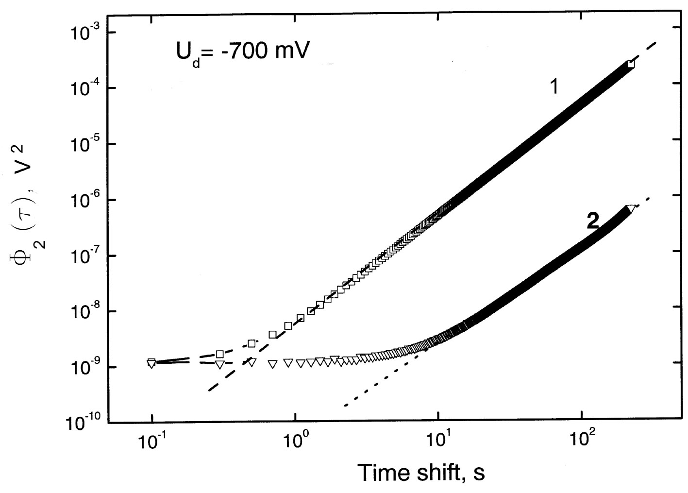
Figure 1. Structural functions of a second order for polarization voltage curves corresponding to the PSi sample at polarization currents 50 nA (1) and 5 nA (2). [Times New Roman,10.5 pt]

Photos have to be of sufficient contrast to survive off-set printing from the original. An example is given here [Times New Roman,10.5 pt]

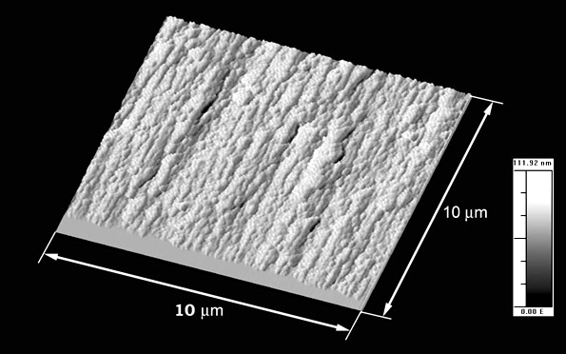

Figure 2. AFM image of cross-sectional view of PSi formed on n⁺-Si at 100 mA/cm²

In the case you need to introduce equations please use Equation Editor of MS Office in order to avoid mistakes during downloading and printing of your text. Example is here.
$Φ_{(p)}(τ)≈g(p)⋅σ ^{p}⋅{\left[1−Γ ^{−1}(H)⋅Γ (H,τ/{T_{1}})\right]}^{p},$ (1)
(1)
3. DISCUSSION [Times New Roman, Capital, 10.5 pt, Bold]
This section may be merged with the previous one due to a limited size of the Extended Abstract. [Times New Roman,10.5 pt]
4. CONCLUSIONS [Times New Roman, Capital, 10.5 pt, Bold]
- Please briefly outline the conclusions which you have got in your work. [Times New Roman,10.5 pt]
ACKNOWLEDGEMENTS [Times New Roman, Capital, 10.5 pt, Bold]
It is a good practice to acknowledge official organizations and individuals who have helped you to perform your work and present is at the Conference. [Times New Roman,10.5 pt]

REFERENCES [Times New Roman, Capital, 10.5 pt, Bold]
- E.M. Paul, A.J. Ricco, M.S. Wrighton, J.Phys Chem., 89, 1441 (1985). [Times New Roman,10.5 pt]
- Wang, E.M. Scherr, A.G. MacDiarmid and A.J. Epstein, Phys. Rev. B, 45, 4190 (1992).

